MARCH MONTHLY TASKS

BGGC GARDEN RESEARCH 2019

PRUNE, CLEAN-UP & FERTILIZE

[] GOOD TIME TO PLANT TREES & SHRUBS, BUT NOT DOGWOOD or MAGNOLIA

[] CLEAN UP ROSES and TRIM TO SHAPE

[] SPREAD MANURE or COMPOST WHEN GROUND IS FROZEN

[] CUT BACK ORNAMENTAL GRASSES & DEAD TOPS OF PERRENIALS

[] PRUNE ROSE of SHARON, HYDRANGEA & WEIGELA

PERRENIALS & FLOWERING PLANTS

[] PLANT PANSIES & VIOLAS FOR EARLY COLOR

[] START DAHLIA, BEGONIA TUBERS & CANNAS INDOORS FOR MAY PLANTING

[] PERRENIAL PRIMROSE & ENGLISH DAISIES ARE READY TO PLANT

VEGETABLE GARDEN

[] START PEPPERS, TOMATO & EGGPLANT SEEDS INDOORS

[] LATE IN THE MONTH PLANT KALE, CABBAGE FAMILY, PEAS & LETTUCE

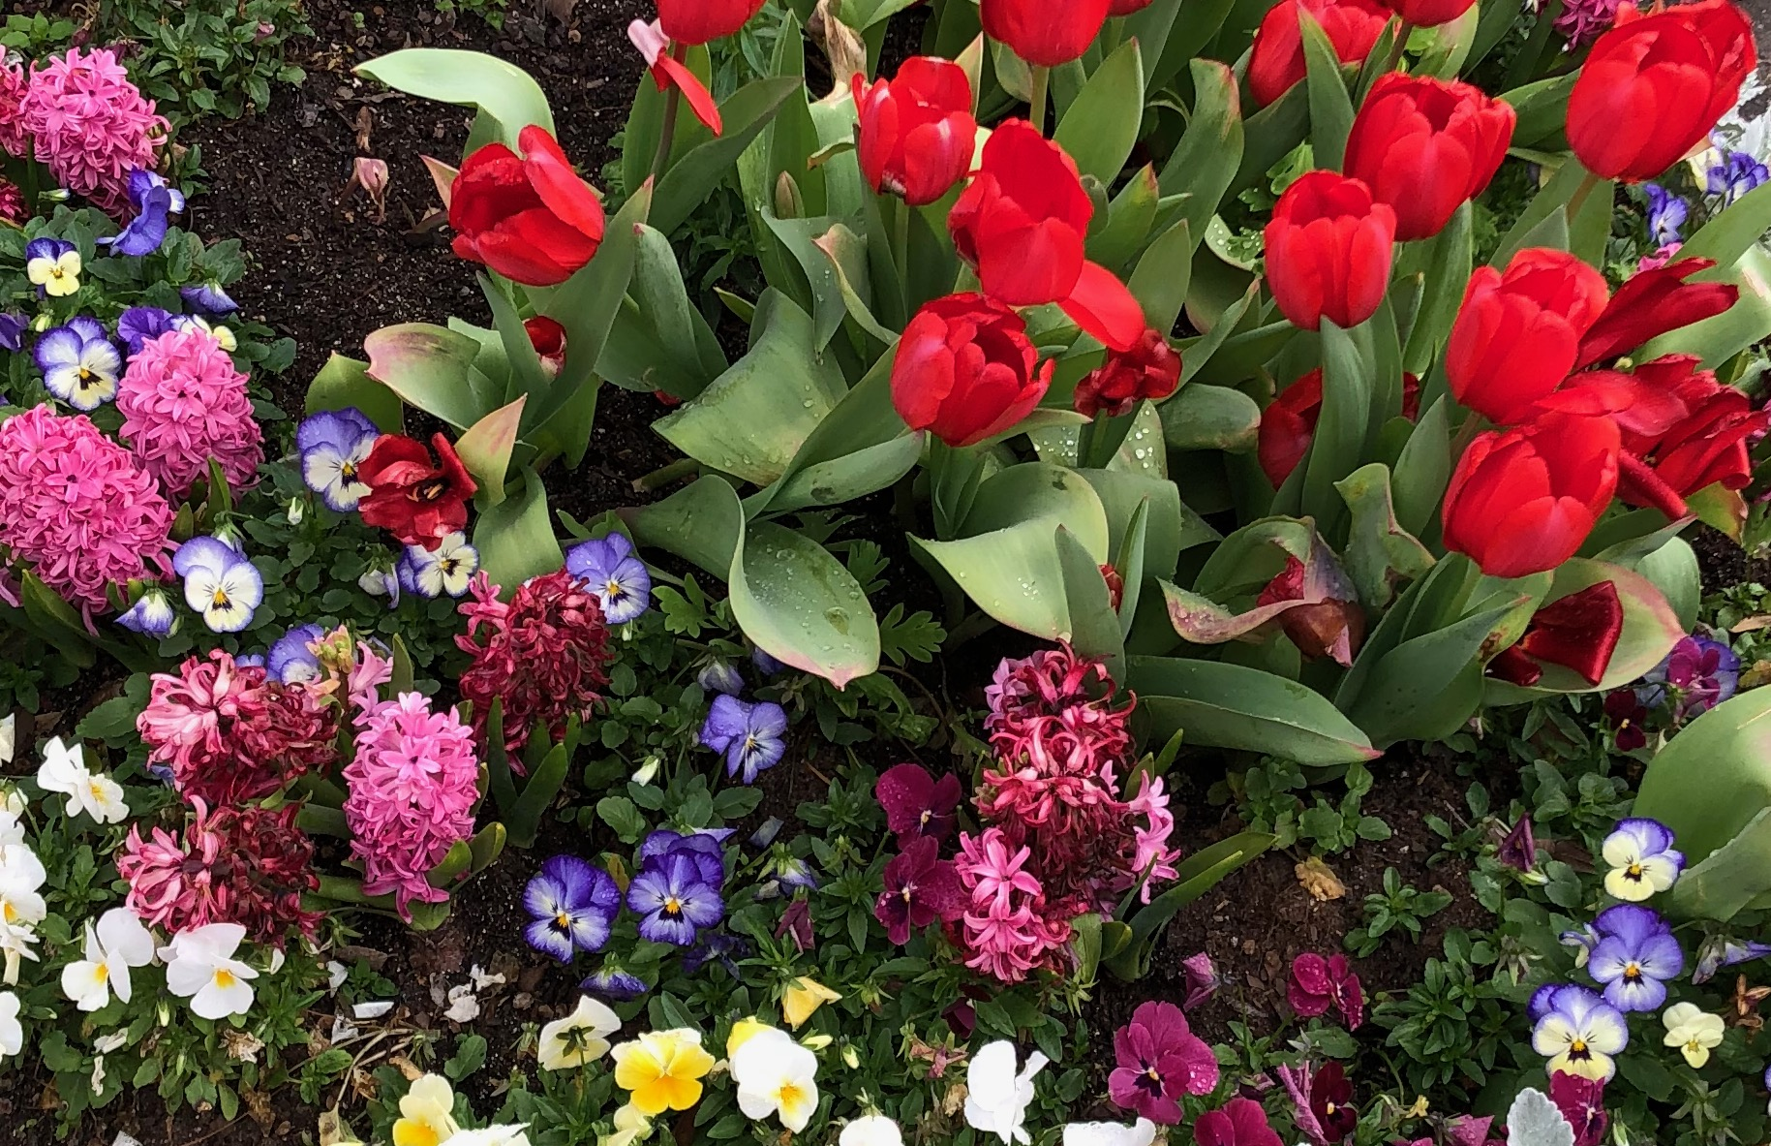
HAPPY SPRING!
SOURCES/ www.daytonnursery.com and www.petittigardencenter.com

